Quarterly Report – Public Page

Date of Report: 12th Quarterly Report- September 30, 2025
Contract Number: 693JK32210002POTA
Prepared for: Government Agency: DOT and Co-funders
Project Title: Monitoring the Long-Term Compatibility of Vapor Corrosion Inhibitor and Cathodic Protection Associated Components
Prepared by: Pipeline Research Council International, Inc.
Contact Information: Janie Norton, email: jnorton@prci.org
For quarterly period ending: September 30, 2025

1: Items Completed During this Quarterly Period:

Item # | Task # | Activity/Deliverable | Title | Federal Cost | Cost Share
39 | 5 | Quarterly status report & project management | Submit 12th quarterly report | - | -

2: Items Not Completed During this Quarterly Period:

None.
3: Project Financial Tracking During this Quarterly Period:

Note that this chart reflects Federal share only.
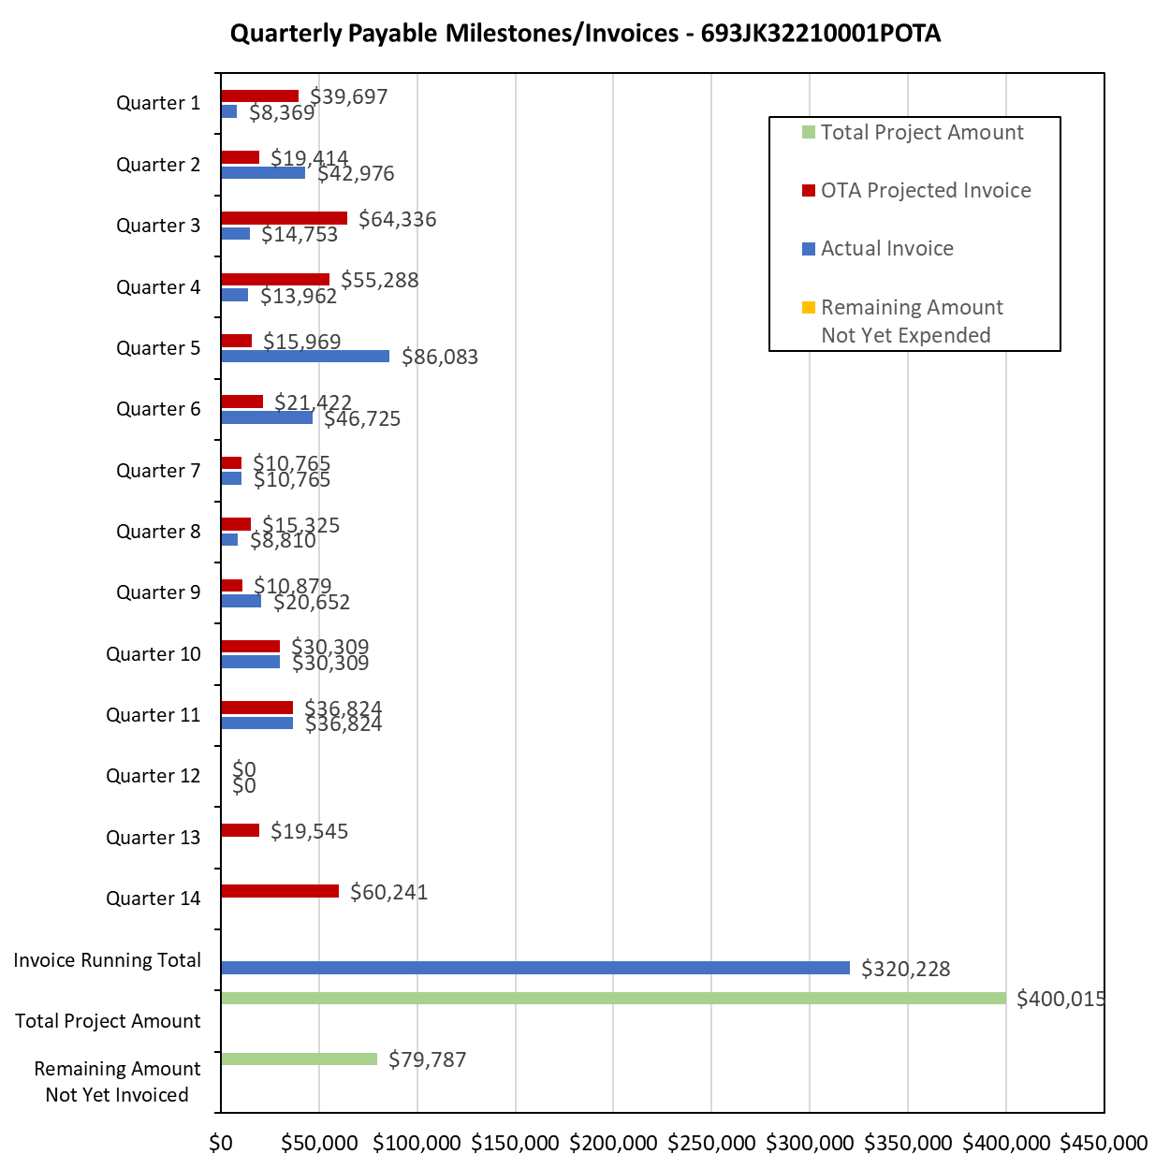

4: Project Technical Status:

Item 39, Task 5 ⎯ Quarterly status report & project management. Submit 12th quarterly report: The 12th quarter project meeting was held on September 4, 2025. This item has been completed, and it partly satisfies item 25 in Attachment 2 Project Deliverables. It also links to item 13 as listed in Attachment 1 Team Project Activities. The quarterly meeting links to item 11 as listed in Attachment 1 Team Project Activities.

5: Project Schedule:

The project schedule is on track as per the revised schedule.

